Statement of Work

Grainger PLC
Axis Void Management

Version 1.1
March 26, 2024

Contents
1 Statement of Work 3
1.1 Overview 3
1.2 Objectives 3
1.3 Delivery Approach 4
1.4 Responsibilities 5
1.5 Availability 6
1.6 References 6
2 Project Risks, Assumptions & Exclusions 7
2.1 Risks 7
2.2 Assumptions 7
2.3 Exclusions 8
3 Cost and Timelines 9
4 Acceptance 11

Statement of Work

Overview
Grainger plc is in the process of working with Axis (a third party vendor) to make Axis responsible for the void works carried out in all units within the South region of the Grainger plc portfolio. The project will leverage the data captured within the Grainger plc Salesforce org during the existing End of Tenancy (EoT) process to notify Axis of the dates and details of void works required for each unit for which the tenancy is ending. The notification should be as automated as possible, but may have some manual steps for Release 1 due to aggressive timelines and limited integration capabilities on Axis’s side.
In addition, enhancements to the existing EoT process will be required to capture new information that is required for Axis (e.g. PVI time in addition to PVI date).

Objectives
The objectives of this project are to:
- Conduct sufficient upfront analysis in order for Open Box to be in a position to commence development.
  - Document the solution requirements and outcomes to be delivered in an initial, prioritized project backlog.
  - Write user stories, with detailed acceptance criteria, for the features that are anticipated to be addressed first. Acceptance criteria will be reviewed and agreed with Grainger.
- After initial analysis, provide a revised forecast of the estimated effort, cost & timeline required to deliver the project backlog.
- Deliver the following solution:
  - Enhancing the existing EoT process to capture additional information required by Axis. This will be done by requesting required information from users during the EoT task closure process and storing this in new fields created on the End of Tenancy object.
  - Creating a 2nd variation of the existing EoT process to cater for Grainger Trust units whose tenancies are not maintained in Salesforce. The “EoT lite” process would allow the creation of an EoT record in Salesforce without a linked Tenancy record and would allow users to capture the key details required for Axis directly on the EoT record.
  - Functionality developed within Salesforce to send an email on a daily basis to a designated Axis email address. The email will contain an Excel file with void works information (e.g. works type), dates (e.g. PVI date & time), unit details (e.g. address) for EoT’s meeting the criteria below:
    - EoT is in progress
AND
    - EoT is related to a unit that is serviced by Axis
AND
    - EoT was created or edited in the past day AND changes were made to one or more of the “Axis fields” (those fields included in the above mentioned Excel file). i.e. the daily email will only include EoT’s where Axis-relevant fields have been modified in the previous day, it will not include all EoT’s modified in the previous day.
  - Configuring Case management in Salesforce to manage approval requests from Axis, annotated as #4 and #6 in Figure 1 below. Approval requests will be sent by Axis via email and captured in Salesforce by email-to-case, allowing a Grainger team to view and manage all approval requests in a single system.
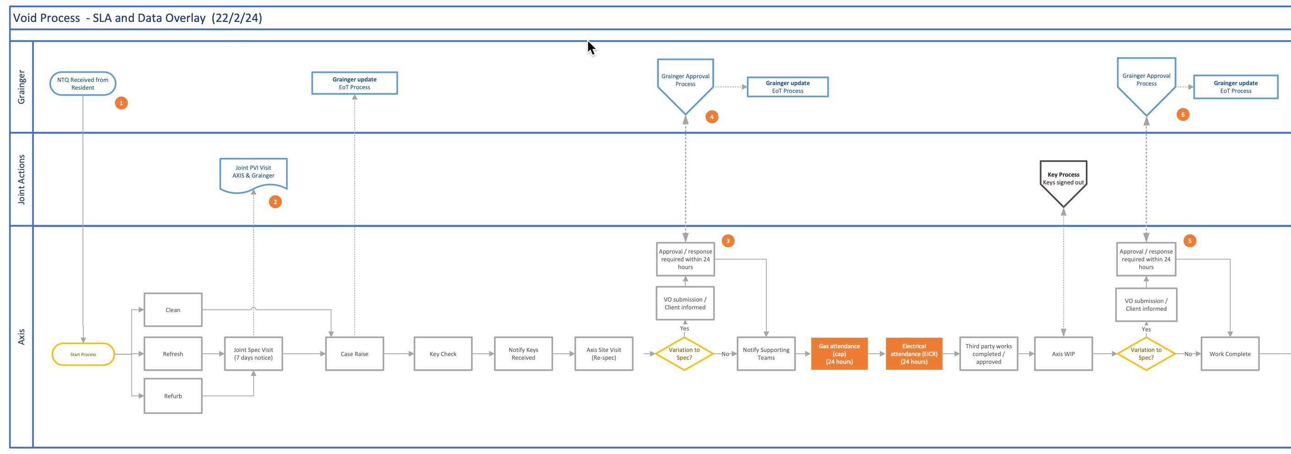
Figure 1 Axis Void Process

Delivery Approach
It is understood that Release 1 needs to be deployed to production by early May. Due to these aggressive timelines, the delivery approach will be based on the Kanban agile framework where features will be analysed, developed, tested and delivered continuously throughout the project.
A backlog will be maintained to track outcomes to be delivered and indicate priority of these outcomes relative to each other. The backlog will be a living artifact that will evolve as Open Box and Grainger plc collaborate. Grainger plc stakeholders will have access to the backlog which will serve as the single source of truth with regards to scope.
Grainger plc representatives will be required to particulate in backlog refinement, demos and stand up ceremonies.

UAT
Grainger will be responsible for testing the functionality delivered and ensuring that the solution is performing as expected during the UAT period.
Issues raised will be classified as bugs or enhancements. Bugs will be fixed during the UAT period. Any other enhancements or new requirements will be added to the backlog for future development or addressed by extending the project timelines (by mutual agreement between Grainger plc and Open Box).

Support
Open Box will provide hypercare support for 10 working days immediately following the production deployment.

Responsibilities
- Open Box will be responsible for:
  - Providing the services described in the project Objectives.
  - Delivering a progress report to Grainger plc on a regular basis that will include:
    - General status update & project health
    - Project risks
    - Milestones and timelines
    - Any significant changes to project scope, cost, or timeline forecasts.
  - Updating the EOT user manual to incorporate changes made to the EOT process as part of this project.
- Grainger plc will be responsible for:
  - Making key personnel and stakeholders available throughout the project lifecycle, including participation in the activities detailed in the Delivery Approach.
  - Providing any knowledge required about the Axis process and requirements
  - Ensuring there are no other projects planned or in operation that may hinder this project.
- Axis will be responsible for:
  - Making key personnel available to answer process questions and participate in testing where required (e.g. end-to-end testing of Case management functionality)

Availability
- Open Box resources will be contactable and available for meetings via conference calls/video conferences:
- Monday to Friday 9am – 6pm South African time (GMT +02:00) which currently corresponds to 7am – 4pm (GMT), excluding public holidays.
- A defined escalation path will be provided to the agreed project manager should urgent assistance be required outside of these times.
- All work will be completed by Open Box offsite.
  - It is not expected that the project will require Open Box resources on-site. Where onsite personnel are required, all reasonable expenses for travel and subsistence shall be reimbursed by Grainger plc. Open Box shall not bill any mark-up or administration fee for any such expenses. Approval for expenses shall be obtained from Grainger plc prior to being incurred.

References
- Axis Grainger Void Process - SLA & Data Overlay 22-2-24.pdf (March 5, 2024)
- Business Optimisation - RM with Axis Voids v0.4(draft).xlsx (March 6, 2024)
- Grainger, Open Box meeting: R&M Voids Process / EOT (Wednesday, 6 March 2024)
- Grainger, Open Box meeting: R&M and Salesforce Discussion (Monday, 11 March 2024)

Project Risks, Assumptions & Exclusions

Risks
It is understood that Grainger plc are looking for a go-live date in early May. This is an aggressive timeline in which to incorporate further requirements analysis, development and quality assurance (QA) and final user acceptance testing (UAT).
Open Box believes a Kanban methodology is the best approach to mitigate such risks, with incremental analysis and delivery.
It should be noted that the functionality described in this document relates only to work to be done in Salesforce. The overall “Axis Void Management” process may require other systems and processes to be adjusted outside the scope of this project.

Assumptions
The following assumptions have been made; incorrect assumptions may affect cost and timelines.
- Due to timelines and limited integration capabilities within Axis, Release 1 is expected to be a somewhat manual process. This will be refined in future releases, with the ultimate goal being a fully automated API integration.
- GREP integration is not required for Release 1.
- The Grainger plc Salesforce org will not be responsible for sending notifications/reminders to Axis service agents. The daily email from the Grainger plc Salesforce org will be used by Axis to update their system(s) (Microsoft Dynamics and others) with void work details only. All service agent orchestration and management will be Axis’s responsibility.
- Case management functionality implemented for Release 1 will cover the basic functionality to capture a new case via email-to-case, allow agents to manage a case until closure, tracking activities and sending emails during this process. SLA’s, knowledge articles, omni channel (e.g. live web chat, WhatsApp) and integrated telephony (CTI) are out of scope for Release 1.

Exclusions
The following is not included in the cost or scope of this project:
- Data clean-up or data migration.
  - It is expected that Grainger will cleanse or populate any unit, building or block data in Salesforce that is required for the Axis void management process
- Salesforce costs, license fees, subscriptions, or services.
- Hardware and infrastructure.
- Solution documentation, other than user stories.
- End-user training, change management or new / updated training materials.

Cost and Timelines
Open Box will provide an agile delivery team to develop, test and deploy the solution on a Time & Materials (T&M) basis at a rate of £120/hour.
The team will be staffed to include the following skillsets as required:
- Salesforce Technical Architect
- Business Analyst
- Developers
- Quality Assurer
- Project Manager

The estimated effort and costs per phase are shown in the table below:
Phase | Hours | Lower Bound | Upper Bound
Analysis | 60 - 78 | £7,200 | £9,360
Build | 200 - 260 | £24,000 | £31,200
Project Management | 12 - 15.6 | £1,440 | £1,872
UAT | 40 - 52 | £4,800 | £6,240
Production | 5 - 6.5 | £600 | £780
Total | 317 - 412 | £38,040 | £49,452

Assuming a start date in week commencing 25th March 2024, the anticipated timeline is shown below:
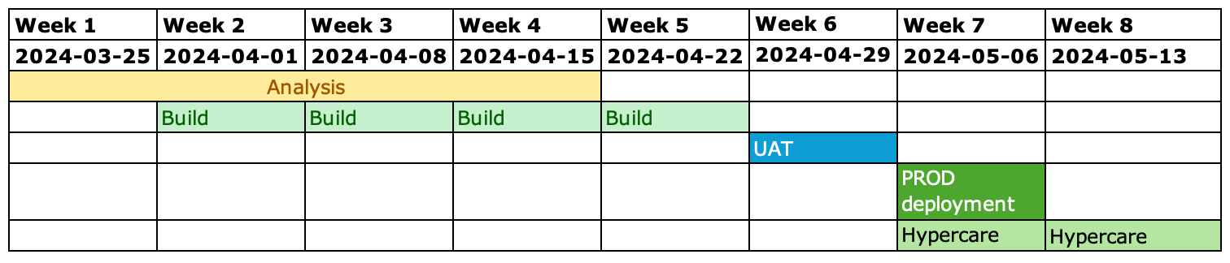
Please note this timeline is aggressive and is driven by our understanding that the new process needs to be available in production by early May. Timelines may need to be adjusted based on other requirements (e.g. Grainger plc and/or Axis ability to complete UAT within 1 week).
The total duration of the project is therefore expected to be 6 weeks as well as an additional 2 weeks of hypercare support.
The total cost is therefore estimated to be between £38 040 and £49 452.
These costs and timelines are forecasts. Any expected variations will be communicated via the weekly project status reports provided by Open Box.
All amounts are quoted in GBP and exclude VAT, if applicable.
The project cost will be billed monthly, in arrears, up until the completion of the final project phase. Cost will be reported to Grainger on a in the weekly project management report during the course of the project. The cost will not exceed the upper limit of £49 452 without prior consultation.
This quotation is valid for 30 days and is assumed to start on 25th March 2024 or during the following 1-2 weeks, contingent on operational factors.

Acceptance
The parties hereto, each acting under due and proper authority, have executed this Agreement as of the day, month and year first written below.

For and on behalf of Open Box Software For and on behalf of Grainger plc

Signature: _____________________ Signature: _____________________
Name: Sam Duncan Name:
Position: Salesforce Director Position:
Date: _____________________ Date: _____________________

